**PEDESTAL MIST FANS:**

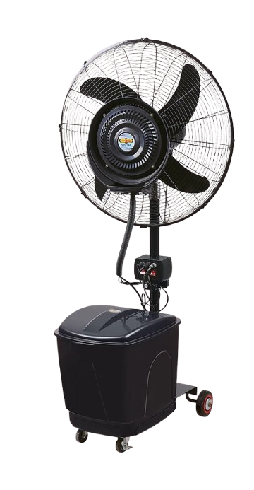

**Price: 15,400.00**

The Pedestal Mist Fan is a versatile and portable cooling solution, perfect for indoor and outdoor spaces. With its adjustable pedestal design, this fan can be customized to fit various environments, providing a refreshing mist of water and powerful airflow to keep you cool. Its compact size, energy-efficient design, and easy mobility make it ideal for homes, offices, patios, and gardens, offering a convenient and effective way to beat the heat.

**Key features of pedestal mist fans include:**

* **Adjustable Height:** Allows customization of airflow direction.
* **Misting Function:** Releases a fine mist for enhanced cooling.
* **Oscillation:** Distributes cool air over a wider area.
* **Portable Design:** Easy to move and position.
* **Adjustable Fan Speed:** Offers control over airflow intensity.
* **Energy Efficiency:** Consumes less power compared to air conditioning.